Date | 28.09.2026
Team ID | SWTID-2026-6482
Project Name | Auto Ticket Classification using Flow Designer

Project Designing Phase – III
2) Solution Architecture

Solution Architecture Overview
The solution architecture is built entirely on ServiceNow platform using Custom Table and Flow Designer no-code automation. No external ML model or integration is used as per the PDF scope - it is purely keyword-based classification.
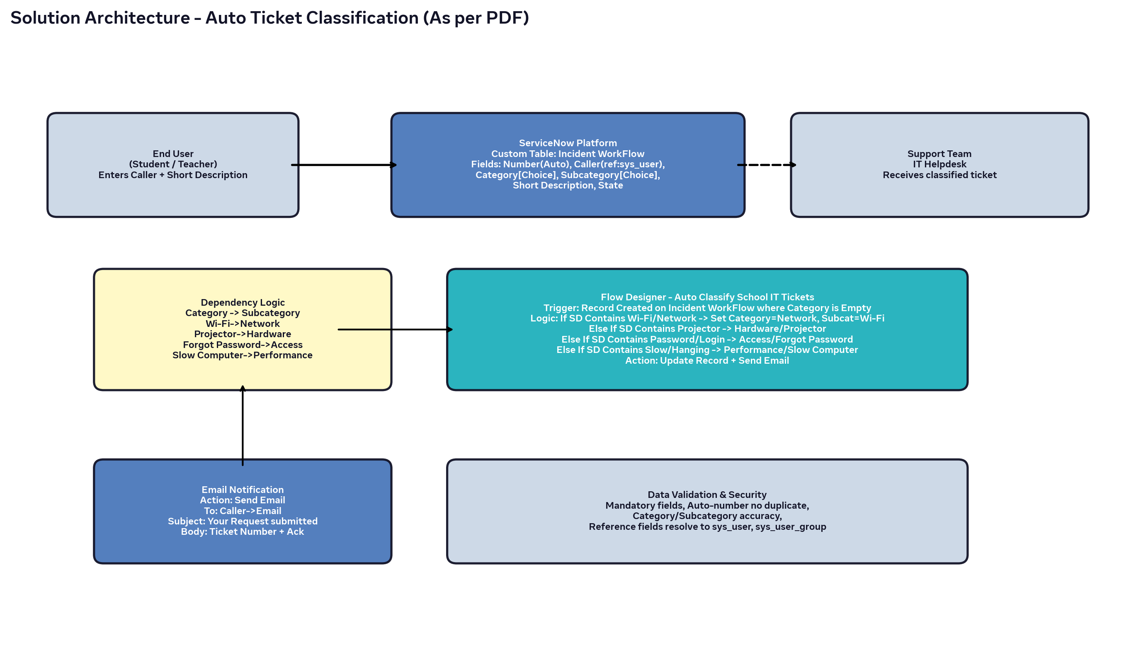

Architecture Components (As per PDF)
Component | Configuration (From PDF) |  |  | Purpose
Custom Table | Label: Incident WorkFlow, Auto Number = true, Create module = false |  |  | Store ticket records with auto-number
Fields | Caller (Reference sys_user), Category [Choice: Network,Hardware,Access, Performance], Subcategory [Choice: Wi-Fi,Projector,Forgot Password,Slow Computer], Short Description (String), State [New,In progress,On hold,Resolved,Closed], Assigned Group (ref sys_user_group) |  |  | Structured data capture
Dependency Logic | Subcategory dependent on Category: Wi-Fi->Network, Projector->Hardware, Forgot Password->Access, Slow Computer->Performance. Config via Dictionary -> Advanced view -> Dependent field |  |  | Dynamic choice filtering, data accuracy
Flow Designer | Flow Name: Auto Classify School IT Tickets, Application: Global, Trigger: Record Created on Incident WorkFlow where Category is Empty |  |  | Orchestration
Flow Logic |  | If SD Contains Wi-Fi/Network -> Update Category=Network, Subcategory=Wi-Fi | Else If Contains Projector -> Hardware/Projector | Else If Contains Password/Login -> Access/Forgot Password | Else If Contains Slow -> Performance/Slow Computer | Auto classification
Email Action |  | Action: Send Email, To: Caller->Email, Subject: Your Request for the issue has been submitted, Body: Ticket confirmation with Number | Instant acknowledgement to caller
Update Set |  | Name: Project Update Set, State: In progress -> Complete, Application: Global, Export to XML | Deployment & sharing

Flow Designer Steps - Exact from PDF
1. Go to All -> Flow designer -> New Flow -> Auto Classify School IT Tickets -> Build Flow
2. Trigger: Record Created, Table: Incident Workflow, Condition: Category is Empty, Done
3. Under Actions Select Flow Logic -> If condition -> SD is Wifi or Network -> Condition: Short description Contains Wi-Fi -> Condition 2: Contains Network -> Done -> Action Update record -> Set Category=Network, Subcategory=Wi-Fi -> Done
4. Else If -> SD is Projector or Hardware -> Condition: Short description Contains Projector -> Done -> Update record -> Category=Hardware, Subcategory=Projector -> Done
5. Else If -> SD is Forgot password -> Condition: Contains Forgot password -> Done -> Update Category=Access, Subcategory=Forgot Password -> Done
6. Else If -> SD is Performance -> Condition: Contains Slow Computer -> Done -> Update Category=Performance, Subcategory=Slow Computer -> Done
7. Email Action Setup: Action Send Email -> To: Caller->Email -> Subject: Your Request has been submitted -> Body: Ticket confirmation message -> Done -> Activate Flow

Data Validation & Security (As per PDF)
• Mandatory fields captured correctly.
• Auto-number generated without duplication.
• Category and Subcategory values stored accurately.
• Reference fields resolve correctly to user and group tables.

